Southern Alberta institute of Technology

Title:

Workshop 4 Create Tables & Load Data

by

**Femi Adams**

Winter 2023

**Dba User Creation**

SQL> create user tea_owner identified by tea_owner;

SQL> grant dba to tea_owner;

SQL> connect tea_owner/tea_owner

SQL> show user

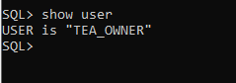

**Tablespace Creation**

SQL> create tablespace tea_data datafile 'D:\ORACLE\ORADATA\TEA\DATAFILE\tea_data01.DBF' size 1g, 'E:\ORACLE\ORADATA\TEA\DATAFILE\tea_data02.DBF' size 1g, 'F:\ORACLE\ORADATA\TEA\DATAFILE\tea_data03.DBF' size 1g autoextend on next 250m maxsize 2g;

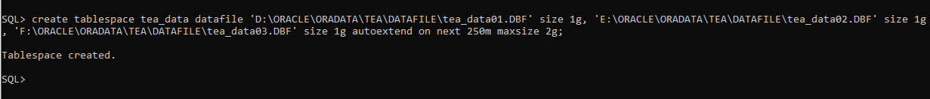

create tablespace tea_data_backup datafile 'D:\ORACLE\ORADATA\TEA\DATAFILE\tea_data_backup01.DBF' size 1g, 'E:\ORACLE\ORADATA\TEA\DATAFILE\tea_data_backup02.DBF' size 1g autoextend on next 250m maxsize 2g;



select tablespace_name from dba_tablespaces;

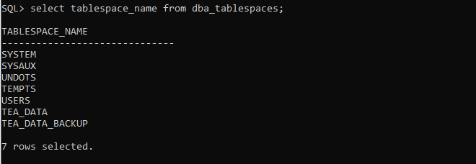

SQL> alter database default tablespace tea_data;



SQL> select owner, segment_type, segment_name from dba_segments where tablespace_name = 'TEA_DATA' order by 1,2,3;

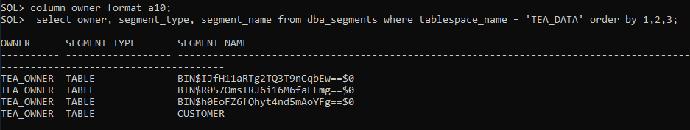

**External Table Creation**

**Customer_load External Table**

Lookup table on original excel data

SQL> create directory tea_customer as 'C:\Temp\Loader';



SQL> grant read, write on directory tea_customer to tea_owner;

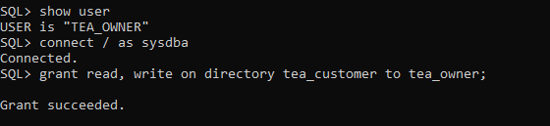

SQL> @C:\connTemp\Loader\teacustomertable.sql

**Create table Customer load file**

create table customer_load

(

customer_id number(6),

first_name varchar2(50),

last_name varchar2(50),

agent_code varchar2(3),

email varchar2(50),

home_phone varchar2(15),

business_phone varchar2(15),

date_of_birth date,

address varchar2(50),

city varchar2(25),

postal_code varchar2(7),

province varchar2(7),

country varchar2(15)

)

organization external

(

type oracle_loader

default directory tea_customer

access parameters

(

records delimited by newline

fields terminated by ","

optionally enclosed by '"'

(

customer_id CHAR,

first_name CHAR,

last_name CHAR,

agent_code CHAR,

email CHAR,

home_phone CHAR,

business_phone CHAR,

date_of_birth date “mm/dd/yyyy”,

address CHAR,

city CHAR,

postal_code CHAR,

province CHAR,

country CHAR

)

)

location ('teacustomer.csv')

)

/

**Supplier_load External Table**

This table is a look up table for the original data in the excel sheet

SQL> create directory tea_supplier as 'C:\Temp\Loader';

SQL> select directory_name, directory_path, origin_con_id from dba_directories;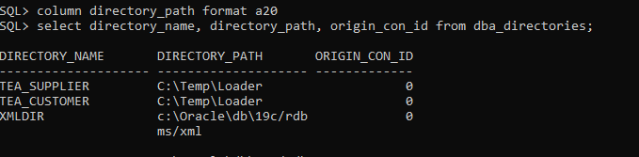

SQL> @C:\Temp\Loader\teasuppliertable.sql

Create table supplier load file

create table supplier_load

(

product_supplier number(6),

product_category number(6),

supplier_office number(1),

product_description varchar2(50),

contact_name varchar2(50),

company varchar2(80),

address1 varchar2(50),

address2 varchar2(50),

city varchar2(25),

province varchar2(2),

postal_code varchar2(7),

country varchar2(15),

phone_number number(12),

fax number(12),

email varchar2(50),

website varchar2(50),

represents varchar2(25),

affiliation varchar2(25)

)

organization external

(

type oracle_loader

default directory tea_supplier

access parameters

(

records delimited by newline

fields terminated by ","

(

product_supplier CHAR,

product_category CHAR,

supplier_office CHAR,

product_description CHAR,

contact_name CHAR,

company CHAR,

address1 CHAR,

address2 CHAR,

city CHAR,

province CHAR,

postal_code CHAR,

country CHAR,

phone_number CHAR,

fax CHAR,

email CHAR,

website CHAR,

represents CHAR,

affiliation CHAR

)

)

location ('teasupplier.csv')

)

/

SQL> select * from supplier_load;

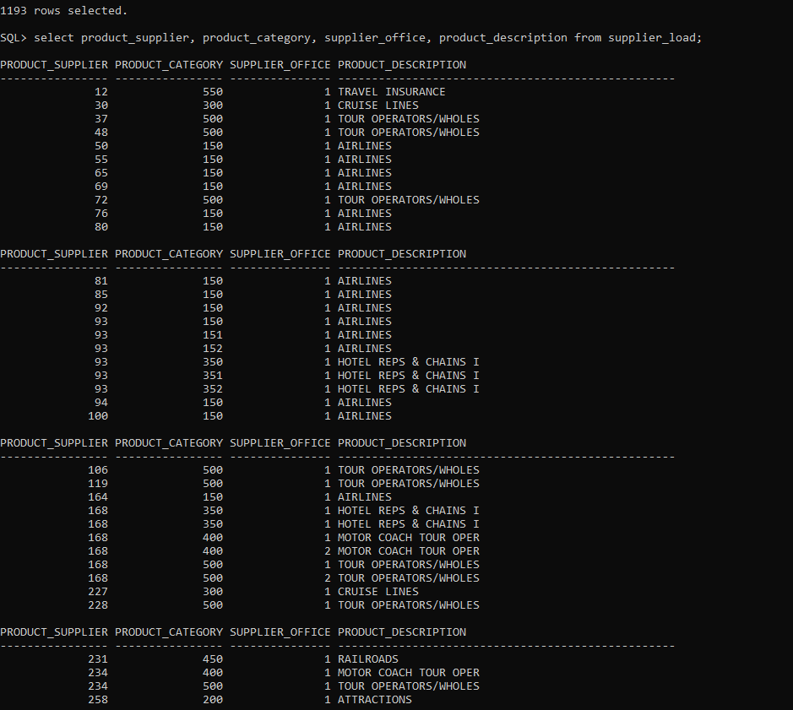

**Main Supplier External Table**

This is a table for the suppliers that represents other suppliers

SQL> @C:\Temp\Loader\teamainsuppliertable.sql

Create main supplier load file

Main_Supplier_Load Table

create table main_supplier_load

(

product_supplier number(6),

product_category number(6),

supplier_office number(1),

product_description varchar2(50),

contact_name varchar2(50),

company varchar2(80),

address1 varchar2(50),

address2 varchar2(50),

city varchar2(25),

province varchar2(2),

postal_code varchar2(7),

country varchar2(15),

phone_number number(12),

fax number(12),

email varchar2(50),

website varchar2(50),

represents varchar2(25),

affiliation varchar2(25)

)

organization external

(

type oracle_loader

default directory tea_supplier

access parameters

(

records delimited by newline

fields terminated by ","

(

product_supplier CHAR,

product_category CHAR,

supplier_office CHAR,

product_description CHAR,

contact_name CHAR,

company CHAR,

address1 CHAR,

address2 CHAR,

city CHAR,

province CHAR,

postal_code CHAR,

country CHAR,

phone_number CHAR,

fax CHAR,

email CHAR,

website CHAR,

represents CHAR,

affiliation CHAR

)

)

location ('teamainsupplier.csv')

)

REJECT LIMIT UNLIMITED;

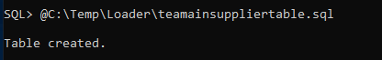

**Company External Table**

This table shows a list of all the suppliers, their names, the supplier_id that represents them and the supplier group they belong to. Company_id is a unique value that is not in the original data, it represents a value of all suppliers in the table. Supplier_rep is a foreign key of company_id in the same table. Supplier_rep is the supplier_id that other suppliers belong to.

SQL> @C:\Temp\Loader\teacompany.sql

Create company load file

create table company_load

(

company_id number(6),

company_name varchar2(80),

supplier_id number(6),

supplier_rep number(6)

)

organization external

(

type oracle_loader

default directory tea_supplier

access parameters

(

records delimited by newline

fields terminated by ","

OPTIONALLY ENCLOSED BY '"'

(

company_id CHAR,

company_name CHAR,

supplier_id CHAR,

supplier_rep CHAR

)

)

location ('teacompany.csv')

)

REJECT LIMIT UNLIMITED;

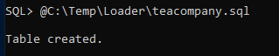

SQL> select * from company_load;

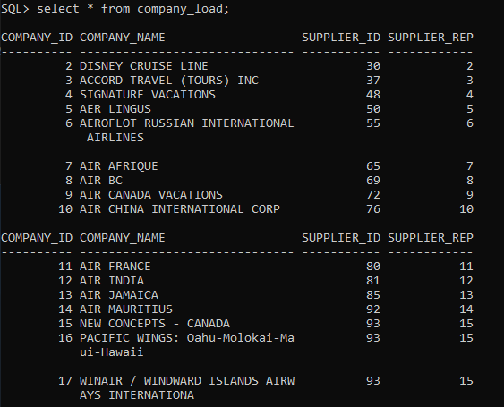

**Sale Load External Table**

Lookup table on original excel data

SQL> create directory tea_sale as 'C:\Temp\Loader';



SQL> @ C:\Temp\Loader\teasaletable.sql

Create sale load file

/*=====Load Sale External Data=====*/

CREATE TABLE sale_load

(

sale_date date,

customer_id number(8),

itinerary_number number(8),

agent_code varchar2(3),

booking_number varchar2(15),

product_category number(3),

product_supplier number(8),

supplier_office number(1),

trip_start date,

trip_end date,

class varchar2(5),

number_of_traveller number(3),

product varchar2(25),

description varchar2(60),

destination varchar2(25),

destination_id varchar2(5),

credit_card varchar2(15),

expiry_date date,

card_number number(20),

billing_date date,

bill_description varchar2(15),

base_price number(11,2),

total_price number(11,2),

billed_amount number(11,2),

agency_fee_code varchar2(3),

agency_fee_amount number(6,2),

agency_commission number(8,2)

)

ORGANIZATION EXTERNAL

(

TYPE ORACLE_LOADER

DEFAULT DIRECTORY tea_sale

ACCESS PARAMETERS

(

RECORDS DELIMITED BY NEWLINE

FIELDS TERMINATED BY ","

OPTIONALLY ENCLOSED BY '"'

(

sale_date date "mm/dd/yyyy",

customer_id char,

itinerary_number char,

agent_code char,

booking_number char,

product_category char,

product_supplier char,

supplier_office char,

trip_start date "mm/dd/yyyy",

trip_end date "mm/dd/yyyy",

class char,

number_of_traveller char,

product char,

description char,

destination char,

destination_id char,

credit_card char,

expiry_date date "mm/dd/yyyy",

card_number char,

billing_date date "mm/dd/yyyy",

bill_description char,

base_price char,

total_price char,

billed_amount char,

agency_fee_code char,

agency_fee_amount char,

agency_commission char

)

)

LOCATION ('teasale.csv')

)

REJECT LIMIT UNLIMITED;

SQL> select * from sale_load;

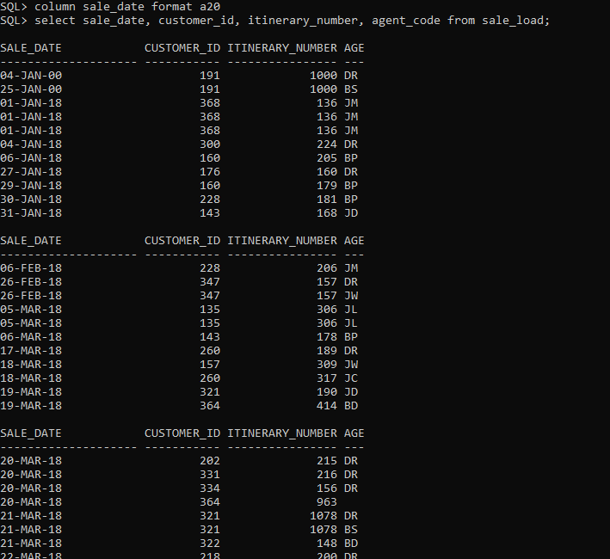

SQL> select count(*) from sale_load;

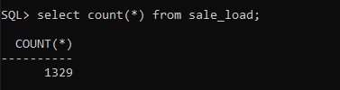

**Product External Table**

SQL> @C:\Temp\Loader\teaproducttable.sql

Create product load file

/*=====Load Product External Data=====*/

CREATE TABLE product_load

(

product_id number(6),

product_name varchar2(50)

)

ORGANIZATION EXTERNAL

(

TYPE ORACLE_LOADER

DEFAULT DIRECTORY tea_sale

ACCESS PARAMETERS

(

RECORDS DELIMITED BY NEWLINE

FIELDS TERMINATED BY ","

OPTIONALLY ENCLOSED BY '"'

(

product_id char,

product_name char

)

)

LOCATION ('teaproduct.csv')

)

REJECT LIMIT UNLIMITED;



SQL> select * from product_load;

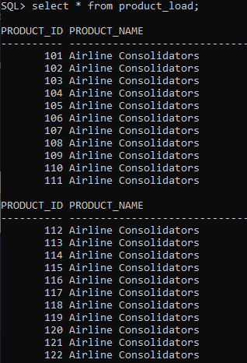

**Payment External Table**

SQL> @C:\Temp\Loader\teapaymenttable.sql

Create payment load file

/*=====Load Product External Data=====*/

CREATE TABLE payment_load

(

payment_id number(6),

cust_credit_card_id number(6),

payment_type varchar2(15)

)

ORGANIZATION EXTERNAL

(

TYPE ORACLE_LOADER

DEFAULT DIRECTORY tea_sale

ACCESS PARAMETERS

(

RECORDS DELIMITED BY NEWLINE

FIELDS TERMINATED BY ","

OPTIONALLY ENCLOSED BY '"'

(

payment_id char,

cust_credit_card_id char,

payment_type char

)

)

LOCATION ('teapayment.csv')

)

REJECT LIMIT UNLIMITED;



**Employee External Table**

SQL> @C:\Temp\Loader\teaemployeetable.sql

Create employee load file

create table employee_load

(

employee_id number(6),

first_name varchar2(50),

last_name varchar2(50),

department_id number(3),

address varchar2(256),

city varchar2(50),

postal_code varchar2(10),

phone_number varchar(16),

email varchar2(50)

)

organization external

(

type oracle_loader

default directory tea_customer

access parameters

(

records delimited by newline

fields terminated by ","

optionally enclosed by '"'

(

employee_id char,

first_name char,

last_name char,

department_id char,

address char,

city char,

postal_code char,

phone_number char,

email char

)

)

location ('teaemployee.csv')

)

REJECT LIMIT UNLIMITED;



SQL> select employee_id, first_name, last_name, city from employee_load;

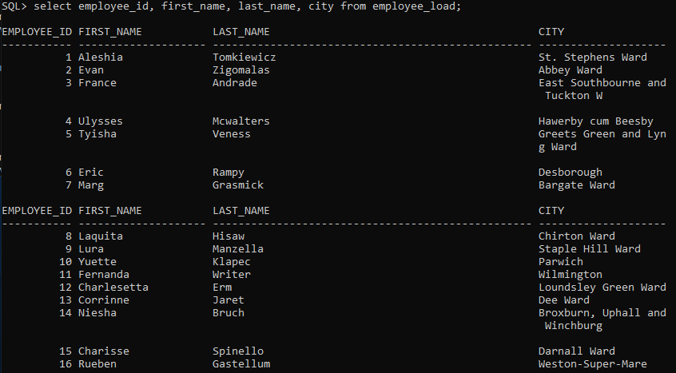

**All Sale External Table**

SQL> @C:\Temp\Loader\teaallsaletable.sql

Create all sale load file

/*=====Load All Sale External Data=====*/

CREATE TABLE all_sale_load

(

sale_id number(6),

employee_id number(6),

customer_id number(6),

itinerary_number number(8),

product_id number(6),

class varchar2(5),

supplier_id number(6),

payment_id number(6),

booking_number varchar2(15),

destination_id varchar2(5),

sale_date date

)

ORGANIZATION EXTERNAL

(

TYPE ORACLE_LOADER

DEFAULT DIRECTORY tea_sale

ACCESS PARAMETERS

(

RECORDS DELIMITED BY NEWLINE

FIELDS TERMINATED BY ","

OPTIONALLY ENCLOSED BY '"'

(

sale_id char,

employee_id char,

customer_id char,

itinerary_number char,

product_id char,

class char,

supplier_id char,

payment_id char,

booking_number char,

destination_id char,

sale_date date "mm/dd/yyyy"

)

)

LOCATION ('teaallsale.csv')

)

REJECT LIMIT UNLIMITED;

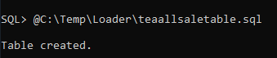

SQL> select * from all_sale_load;

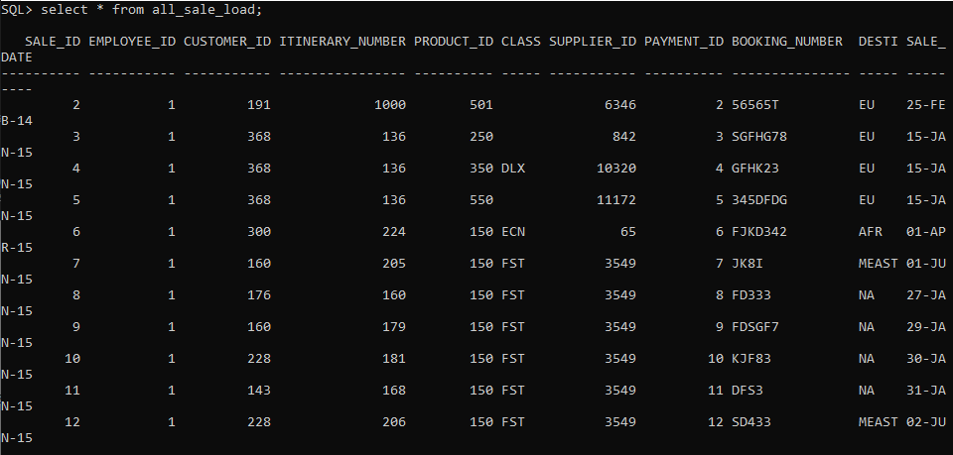

**Booking Number External Table**

/*=====Load Booking Number External Data=====*/

CREATE TABLE booking_number_load

(

booking_number varchar2(15)

)

ORGANIZATION EXTERNAL

(

TYPE ORACLE_LOADER

DEFAULT DIRECTORY tea_load

ACCESS PARAMETERS

(

RECORDS DELIMITED BY NEWLINE

FIELDS TERMINATED BY ","

OPTIONALLY ENCLOSED BY '"'

(

booking_number char

)

)

LOCATION ('teabookingnumber.csv')

)

REJECT LIMIT UNLIMITED;

SQL> @C:\Temp\Loader\teabookingnumber.sql

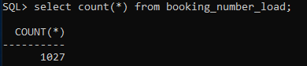

**Itinerary Number External Table**

/*=====Load Itinerary Number External Data=====*/

CREATE TABLE itinerary_number_load

(

itinerary_number number

)

ORGANIZATION EXTERNAL

(

TYPE ORACLE_LOADER

DEFAULT DIRECTORY tea_load

ACCESS PARAMETERS

(

RECORDS DELIMITED BY NEWLINE

FIELDS TERMINATED BY ","

OPTIONALLY ENCLOSED BY '"'

(

itinerary_number char

)

)

LOCATION ('teaitinerarynumber.csv')

)

REJECT LIMIT UNLIMITED;

SQL> @C:\Temp\Loader\teaitinerarynumber.sql

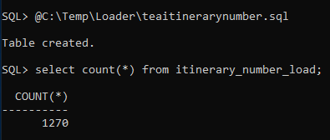

**Table Creation**

**Main Supplier Table**

This is a table for the suppliers that represents other suppliers

SQL> create table main_supplier (supplier_id number(6), supplier_name varchar2(50), constraint supplierid_pk primary key(supplier_id));



SQL> insert into main_supplier select product_supplier, company from main_supplier_load;



SQL> select * from main_supplier;

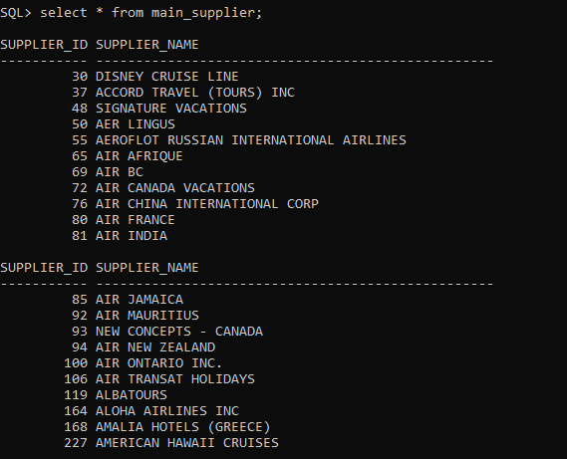

**Supplier Table**

SQL> create table supplier (supplier_id number(6), product_category number(6), supplier_office number(1), product_description varchar2(50),contact_name varchar2(50), company varchar2(80), address1 varchar2(50), address2 varchar(50), city varchar2(25), province varchar2(2), postal_code varchar2(7), country varchar2(15), phone_number number(12), fax number(12), email varchar2(50), website varchar2(50), represents varchar2(25), affiliation_code varchar2(25));

SQL> insert into supplier select product_supplier, product_category, supplier_office, product_description, contact_name,company, address1, address2, city, province, postal_code, country, phone_number, fax, email, website, represents, affiliation from main_supplier_load;

SQL> alter table supplier add (constraint supplierid_pk1 primary key(supplier_id), constraint supplier_supplierid_fk foreign key(supplier_id) references main_supplier(supplier_id), constraint affiliation_affiliation_code_fk foreign key(affiliation_code) references affiliation(affiliation_code));

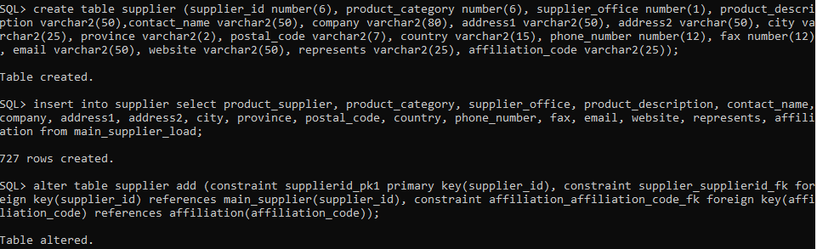

SQL> select supplier_id, company, product_category, contact_name, city, province from supplier;

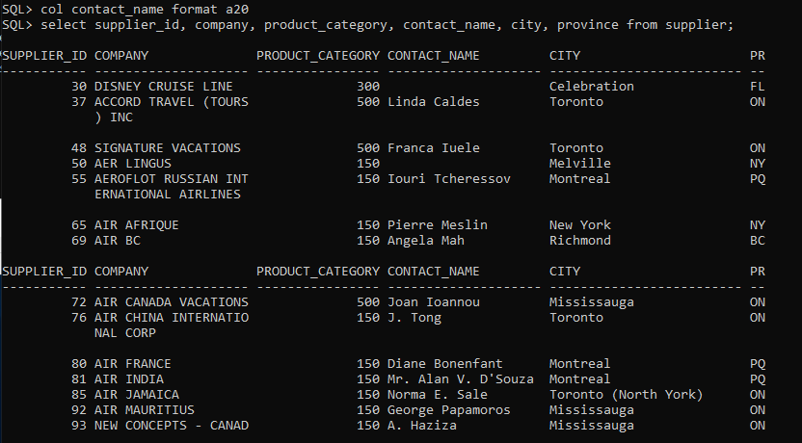

**Customer Table**

SQL> create table Customer (customer_id number(6), first_name varchar2(50), last_name varchar2(50), agent_code varchar2(3), email varchar2(50), home_phone varchar2(15), business_phone varchar2(15), date_of_birth date, address varchar2(50), city varchar2(25), postal_code varchar2(7), province varchar2(3), country varchar2(15)) tablespace tea_data;



SQL> alter table customer add constraint customer_id_pk primary key(customer_id);

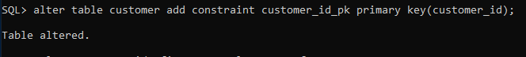

SQL> select * from customer_load;

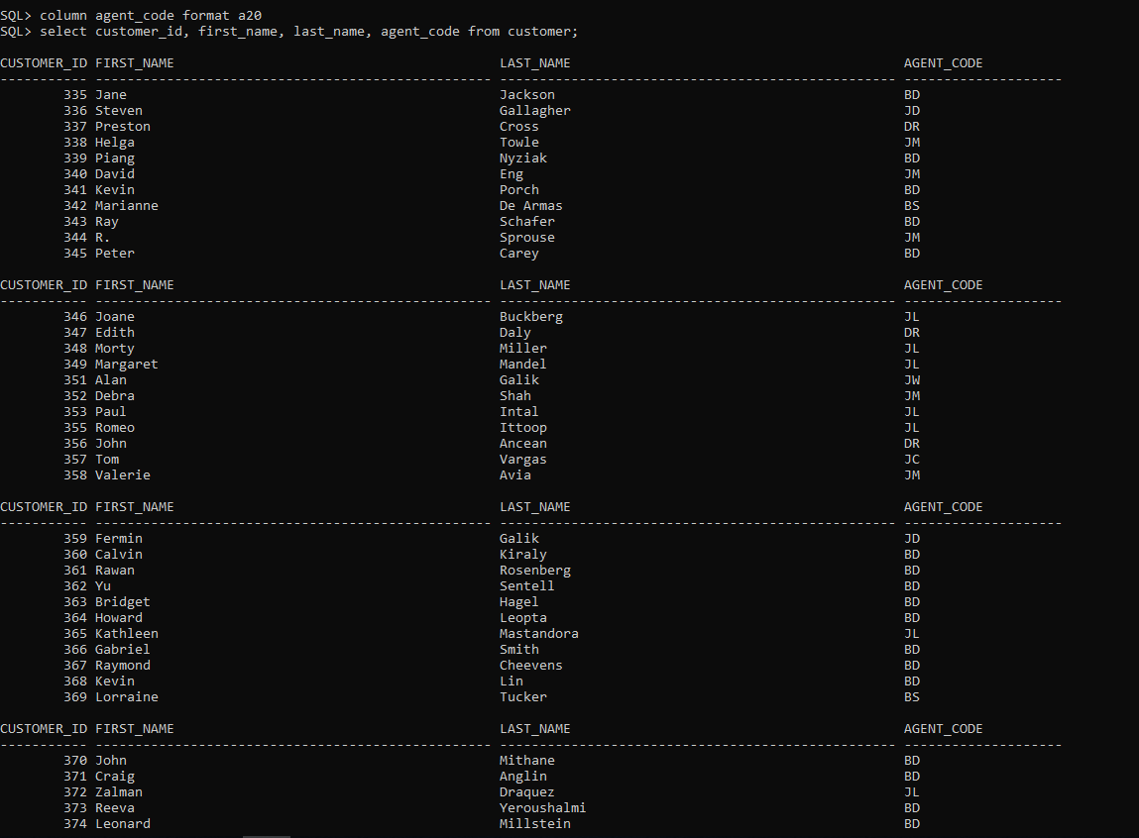

SQL> insert into customer select customer_id, first_name, last_name, agent_code, email, home_phone, business_phone, date_of_birth, address, city, postal_code, province, country from customer_load;

SQL> select * from customer;



SQL> select count(*) from customer;

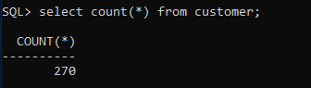

**Payment Type Table**

SQL> create table payment_type (payment_type varchar2(15) not null);

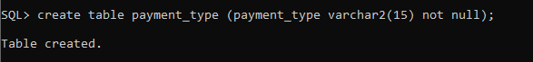

SQL> insert into payment_type select distinct bill_description from sale_load where bill_description is not null;

SQL> alter table payment_type add payment_type_id integer generated by default on null as identity;

SQL> alter table payment_type add constraint payment_type_pk primary key(payment_type);

SQL> select * from payment_type;

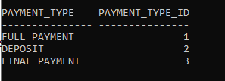

**Payment Method Table**

SQL> create table payment_method (payment_method varchar2(15));

SQL> insert into payment_method values ('cash');

SQL> insert into payment_method values ('cheque');

SQL> insert into payment_method values ('credit card');

SQL> insert into payment_method values ('bank deposit');

SQL> alter table payment_method add payment_method_id integer generated by default on null as identity;

SQL> alter table payment_method add constraint payment_methodid_pk primary key(payment_method_id);

SQL> select * from payment_method;

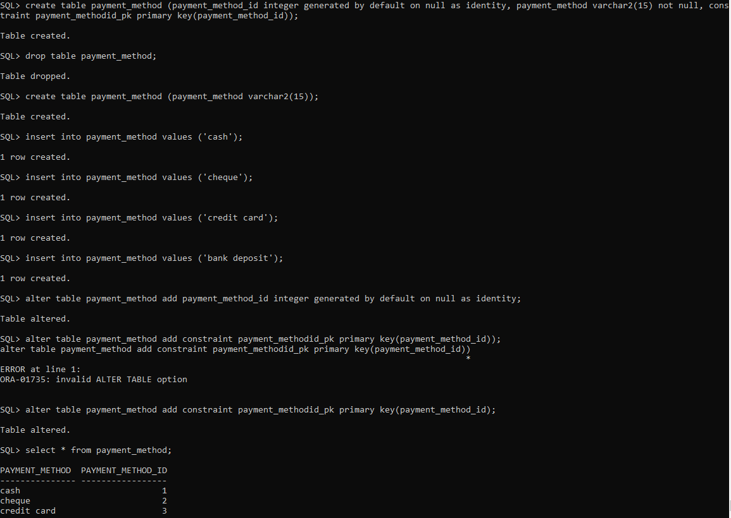

**Cust Credit Card Table**

SQL> create table cust_credit_card (customer_id number(6), card_type varchar2(15), card_number number(16), expiry_date date);

SQL> insert into cust_credit_card select customer_id, credit_card, card_number, expiry_date from sale_load;

SQL> alter table cust_credit_card add constraint customer_customerid_fk1 foreign key(customer_id) references customer(customer_id);

SQL> alter table cust_credit_card add cust_credit_card_id integer generated by default on null as identity;

SQL> alter table cust_credit_card add constraint cust_credit_cardid_pk primary key(cust_credit_card_id);





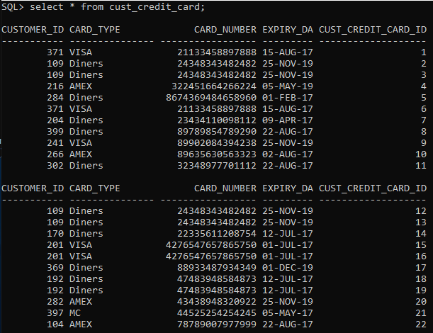

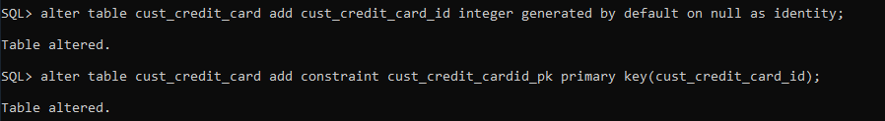

**Class Table**

SQL> create table class (class_type varchar2(4), constraint class_class_type_pk1 primary key (class_type));

SQL> insert into class select distinct class from sale_load where class is not null;

SQL> select * from class;

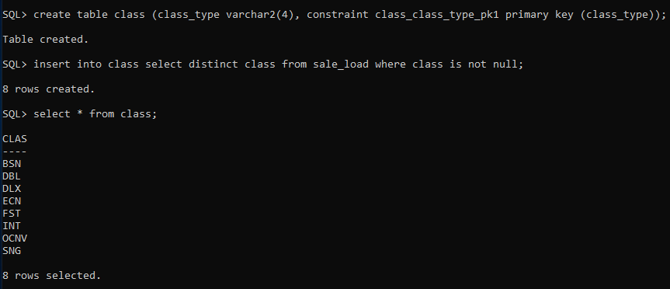

**Destination Table**

SQL> create table destination (destination_id varchar(5), constraint destination_destinationid_pk primary key(destination_id));

SQL> insert into destination select distinct destination_id from sale_load;

SQL> select * from destination;

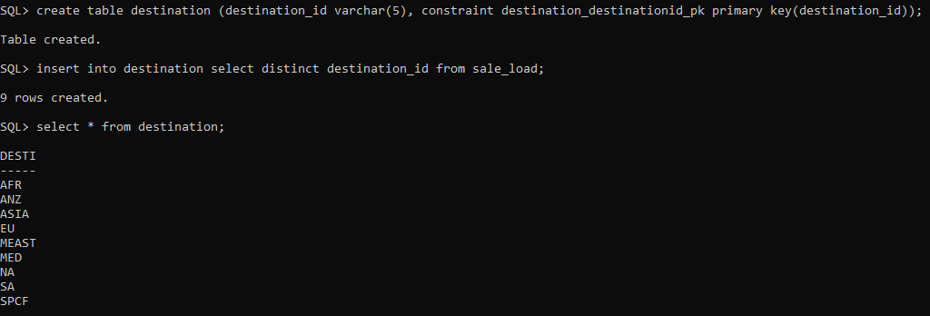

**Affiliation Table**

SQL> create table affiliation (affiliation_code varchar2(25), constraint affiliation_affiliationcode_pk primary key(affiliation_code));

SQL> insert into affiliation select distinct affiliation from supplier_load where affiliation is not null;

SQL> select * from affiliation;

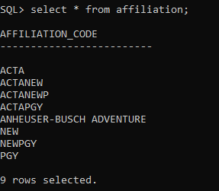

**Company Table**

SQL> create table company (company_id number(6), company_name varchar2(80), supplier_id number(6), supplier_rep number(6));

SQL> insert into company select company_id, company_name, supplier_id, supplier_rep from company_load;

SQL> alter table company add constraint companyid_pk primary key(company_id);

SQL> alter table company add constraint main_supplier_supplierid_fk foreign key(supplier_id) references main_supplier(supplier_id);

SQL> alter table company add constraint company_supplier_rep_fk foreign key(supplier_rep) references company(company_id);

SQL> select * from company;

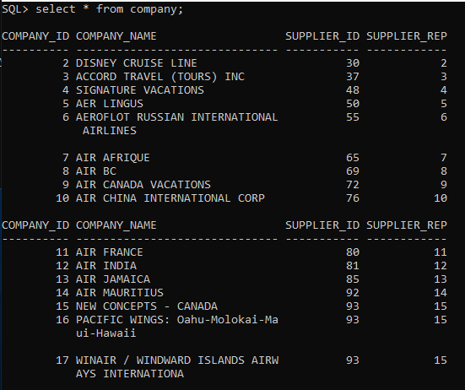

**Product Table**

SQL> create table product (product_id number(6), product_name varchar2(50), constraint productid_pk primary key(product_id));

SQL> insert into product select product_id, product_name from product_load;

insert into product (product_id) values (35);

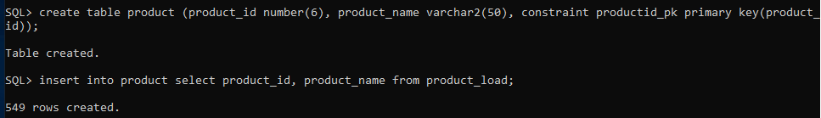

SQL> select * from product;

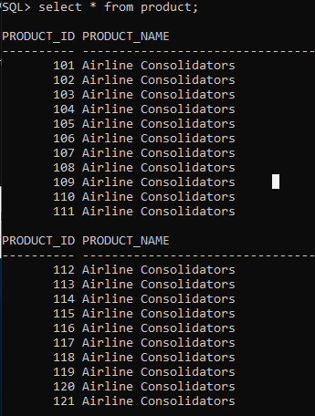

**Payment Table**

SQL> create table payment (payment_id integer generated by default on null as identity, cust_credit_card_id number(6), payment_type varchar2(15));

SQL> insert into payment select payment_id, cust_credit_card_id, payment_type from payment_load;

SQL> alter table payment add (constraint paymentid_pk primary key(payment_id), constraint payment_type_payment_type_fk foreign key(payment_type) references payment_type(payment_type));

insert into payment values (591, 591,'');

insert into payment values (3,3,'');

insert into payment values (4,4,'');

insert into payment values (369,369,'');

insert into payment values (510,510,'');

alter table payment add payment_method_id number;

alter table payment add constraint payment_payment_method_id_fk foreign key (payment_method_id) references payment_method(payment_method_id);





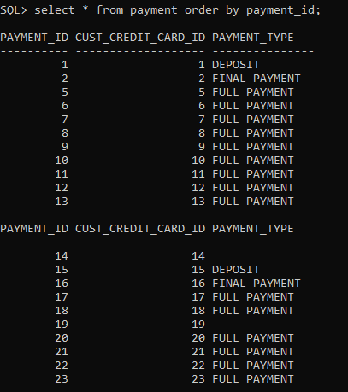



**Commission Table**

Did not add FK on supplier_id because it violates parent key. This is due to the data assigned to us, originally meant to have FK.

SQL> create table commission (amount number(6,2), supplier_id number(6), commission_date date, customer_id number(6), booking_number varchar2(15));

SQL> insert into commission select distinct agency_commission, product_supplier, trip_end, customer_id, booking_number from sale_load;

SQL> alter table commission add (commission_id integer generated by default on null as identity);

SQL> alter table commission add constraint commissionid_pk primary key(commission_id);

SQL> alter table commission add (constraint customer_customerid_fk2 foreign key(customer_id) references customer(customer_id));

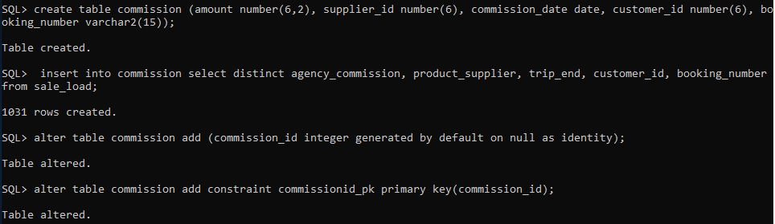 

SQL> select * from commission;

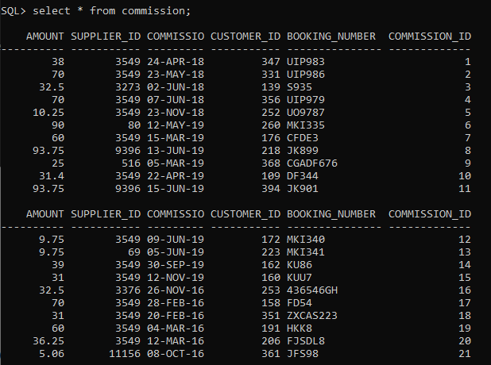

**Itinerary Number Table**

create table itinerary_number (itinerary_number number);

alter table itinerary_number add constraint itinerary_number_pk primary key (itinerary_number);

**Itinerary Table**

SQL> create table itinerary (itinerary_number number(8), customer_id number(6), trip_start date, trip_end date, number_of_travellers number(3), sale_date date);

SQL> insert into itinerary select itinerary_number, customer_id, trip_start, trip_end, number_of_traveller, sale_date from sale_load;

SQL> alter table itinerary add constraint customer_customerid_fk3 foreign key(customer_id) references customer(customer_id);

Not Needed [delete from itinerary where rowid not in (select max(rowid) from itinerary group by itinerary_number);] used to delete duplicate rows.

SQL> alter table itinerary add constraint itinerarynumber_itinerary_number_fk foreign key(itinerary_number) references itinerary_number(itinerary_number);

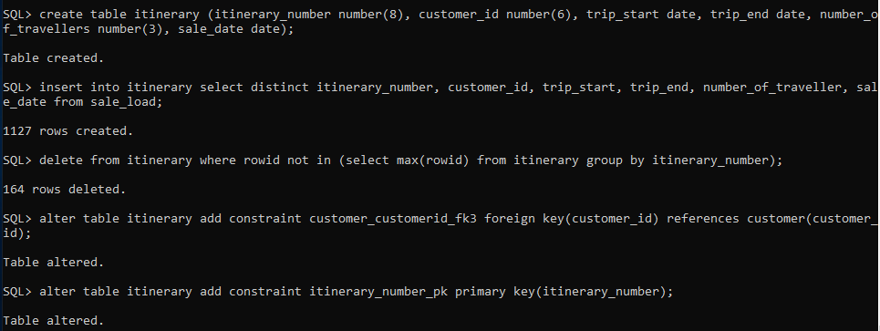

SQL> select * from itinerary order by itinerary_number;

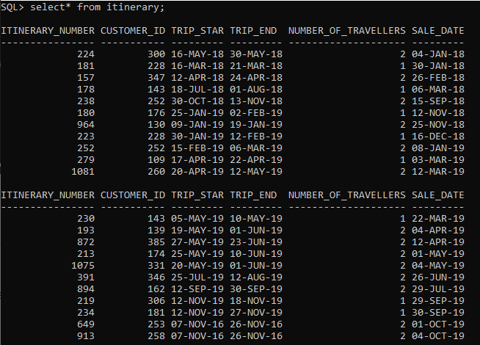

**Booking Number Table**

create table booking_number (booking_number varchar(256));

alter table booking_number add constraint booking_number_pk primary key(booking_number);

insert into booking_number select booking_number from booking_number_load;

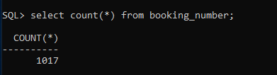

**Booking Table**

SQL> create table booking (booking_number varchar2(15), itinerary_number number(8), product_id number(3), payment_id number(6), billing_date date, base_price number(11,2), billed_amount number(11,2), total_price number(11,2), bill_description varchar2(15), agency_fee_amount number(6,2), agency_fee_code varchar2(3));

SQL> insert into booking select distinct booking_number, itinerary_number, product_id, payment_id, billing_date, base_price, billed_amount, total_price, bill_description, agency_fee_amount, agency_fee_code from booking_load;

Not needed [SQL> delete from booking where rowid not in (select max(rowid) from booking group by booking_number); (used to delete duplicate rows)]

SQL> alter table booking add constraint booking_number_bookingnumber_fk foreign key (booking_number) references booking_number(booking_number);

SQL> alter table booking add (constraint product_productid_fk3 foreign key(product_id) references product(product_id));

alter table booking add constraint payment_paymentid_fk foreign key (payment_id) references payment (payment_id);

commit;

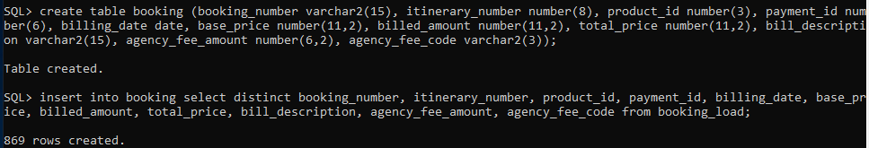



SQL> select * from booking;

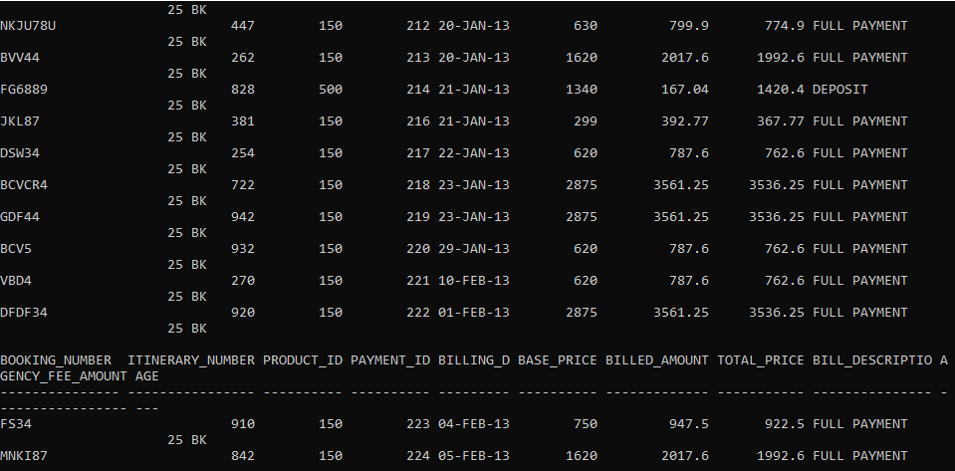



**Department Table**

SQL> create table department (department_id number(6), department_name varchar(50), constraint departmentid_pk primary key(department_id));

SQL> insert into department values (2, 'Airline Booking Department');

SQL> insert into department values (3, 'Cruise Booking Department');

SQL> insert into department values (4, 'Car Rental Department');

SQL> insert into department values (5, 'Insurance Booking Department');

SQL> insert into department values (1, 'Hotel Booking Department');



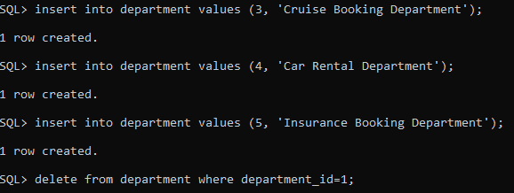

SQL> select * from department;

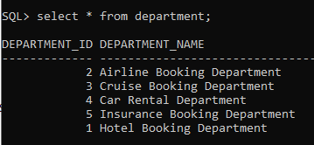

**Employee Table**

SQL> create table employee (employee_id number(6), first_name varchar2(50), last_name varchar2(50), department_id number(3), address varchar2(256), city varchar2(50), postal_code varchar2(10), phone_number varchar2(16), email varchar2(50));

SQL> insert into employee select employee_id, first_name, last_name, department_id, address, city, postal_code, phone_number, email from employee_load;

SQL> alter table employee add (constraint employeeid_pk primary key(employee_id), constraint department_departmentid_fk foreign key(department_id) references department(department_id));

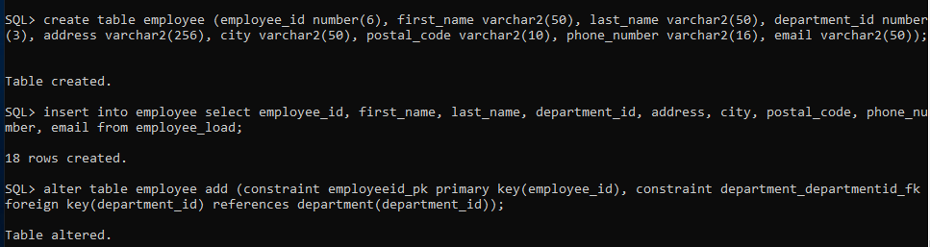

**Sale Table**

SQL> create table sale (sale_id number(6), employee_id number(6), customer_id number(6), itinerary_number number(6), product_id number(6), class_type varchar2(5), supplier_id number(6), payment_id number(6), booking_number varchar2(15), destinaton_id varchar2(5), sale_date date);

SQL> insert into sale select sale_id, employee_id, customer_id, itinerary_number, product_id, class, supplier_id, payment_id, booking_number, destination_id, sale_date from all_sale_load;





SQL> alter table sale add constraint saleid_pk primary key(sale_id);

SQL> alter table sale add constraint employee_employeeid_fk foreign key(employee_id) references employee(employee_id);

SQL> alter table sale add constraint customer_customerid_fk foreign key(customer_id) references customer(customer_id);

SQL> alter table sale add constraint class_class_type_fk foreign key(class_type) references class(class_type);

SQL> alter table sale rename column destinaton_id to destination_id;

SQL> alter table sale add constraint destination_destinationid_fk foreign key(destination_id) references destination(destination_id);

alter table sale add constraint payment_paymentid_fk1 foreign key (payment_id) references payment(payment_id);

delete from sale where supplier_id = 150;

delete from sale where supplier_id = 12;

select sale_id from sale where supplier_id=150;

select sale_id from sale where supplier_id=12;

delete from tax_quote where sale_id=60;

alter table sale add constraint MAIN_SUPPLIER_SUPPLIERID_FK1 foreign key(supplier_id) references main_supplier (supplier_id);

alter table sale add constraint booking_booking_number_fk foreign key(booking_number) references booking_number(booking_number);

alter table sale add constraint product_productid_fk1 foreign key (product_id) references product (product_id);

alter table sale add constraint itinerarynumber_itinerary_number_fk1 foreign key(itinerary_number) references itinerary_number(itinerary_number);

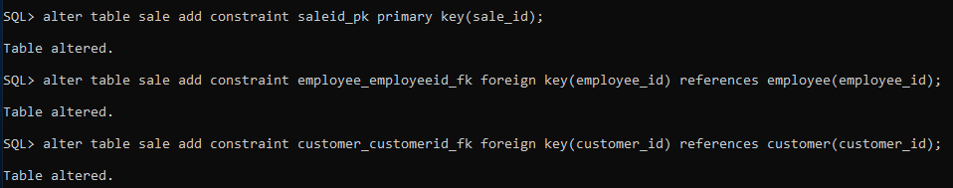







SQL> select sale_id, employee_id, customer_id, booking_number, itinerary_number from sale order by sale_id;

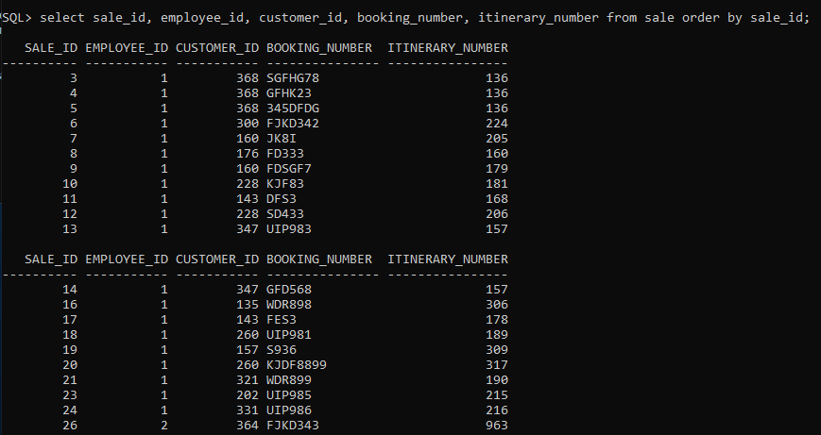

**Tax Quote Table**

Tax quoted to agents by the supplier for different products.

SQL> create table tax_quote (sale_id number(6), constraint sale_saleid_fk foreign key(sale_id) references sale(sale_id));drop

SQL> alter table tax_quote add constraint tax_quoteid_pk primary key(tax_quote_id);

SQL> alter table tax_quote add tax_quote_id integer generated by default on null as identity;

Commit;



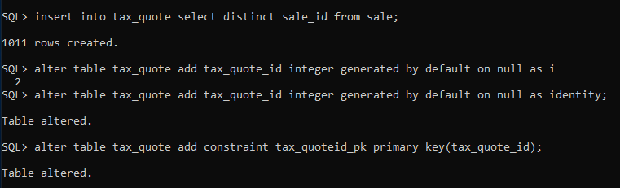

SQL> select * from tax_quote;

